
Substance Abuse
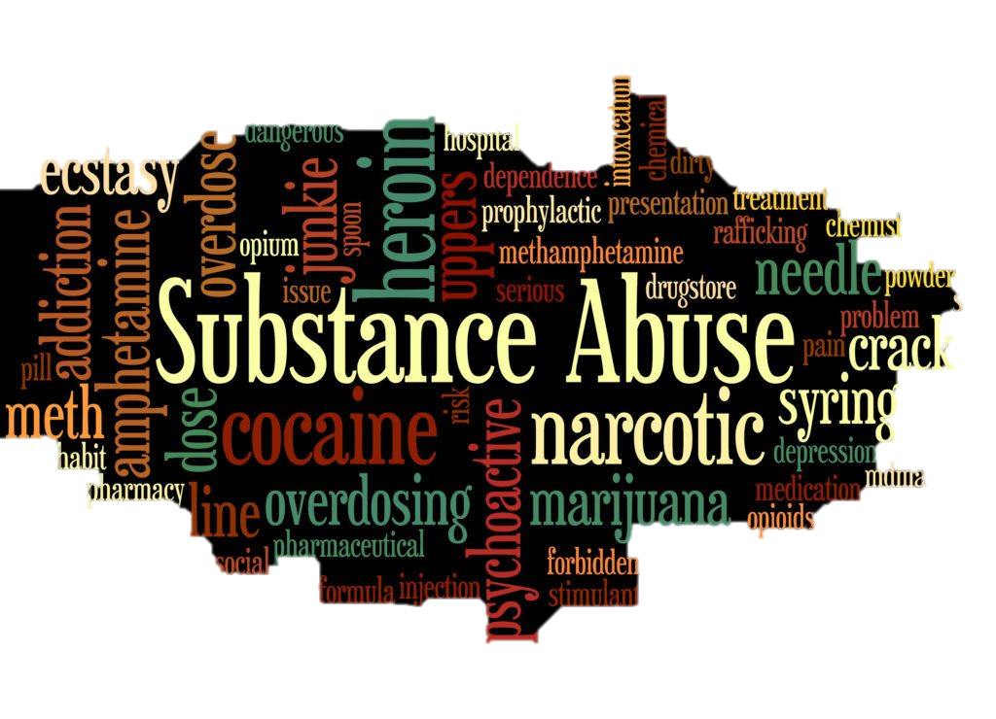
S
ubstance abuse is simply described as the harmful use of any drugs or substance that is responsible for altering the mood of a person. Substance abuse can include; over indulgence of alcoholic drinks and use of other drugs that are legal or not as well as the use of substances that are not drugs. Substance abuse has adverse impacts on the individual, the family of the individual, the community and even the nation.

Impacts of Substance Abuse on an Individual
- Substance abuse has an adverse impact on the brain development of an individual, studies have shown that substance abuse causes problems with the memory, interferes with the neurotransmitters affecting the connections in the brain and inhibits perceptual ability development (Korponay et al., 2017).
- Substance abuse can lead to health complications. Some of the drugs used affect the development of bones and some affect the functioning of the heart leading to complications.
- Substance abuse increases the risk for infection, people under the influence of some substance might have impaired judgment and they might engage in irresponsible acts which might lead them to get infections.
- Also, substance abuse affects the behavior of a person. Scholarly studies have shown that people who abuse substances suffer behavioral problems which include; impulsiveness, hallucinations and paranoia (Korponay et al., 2017).

- Legal consequences; some of the substances abused are illegal and using them might lead to legal consequences.
- Harmful use of the drugs might lead to injuries or even death in some cases.

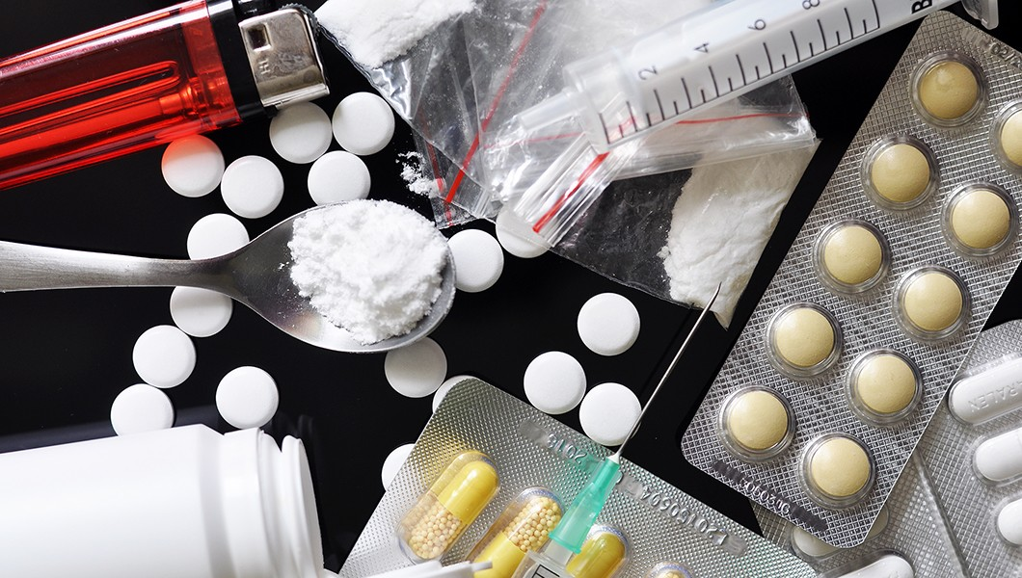

Effects of Substance Abuse on the Family
- Negativism; substance abuse in most cases affects the perception of people and family conversations might be negative in many cases.
- Parental inconsistency as the abuse affects the structure of the family.
- Parental denial can result from substance abuse and might lead to breaking of families (Pestka et al., 2018).


- Unrealistic parental expectations due to substance abuse might also affect the structure of the family.
- Financial problems which arise from substance abuse might reduce the stability of families.

Effects of Substance Abuse on the Community
- Increase in the rate of crime. Substance abuse has been linked with crime.
- Reduced quality of life in the community.
- Poor relationships between members of the society.
- Educational standards are affected by substance abuse. The effect on the behavior of individuals abusing drugs makes it hard for them to concentrate on their studies. Brain development is also affected by the use of drugs making it hard for educational standards to be improved in the community (Pestka et al., 2018).




Effects of Substance Abuse on the Nation
- Individuals who abuse drugs have reduced productivity; this means the country’s productivity will be affected adversely.
- The nation will incur a lot of costs in establishing treatment facilities for individuals suffering from substance abuse.
- Slowed economic development as the workforce will be affected (Mohamad et al., 2018).

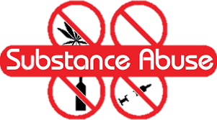

References.
Korponay, C., Kosson, D. S., Decety, J., Kiehl, K. A., &amp; Koenigs, M. (2017). Brain volume correlates with duration of abstinence from substance abuse in aregion-specific and substance-specific manner. Biological Psychiatry: Cognitive Neuroscience and Neuroimaging, 2(7), 626-635.
Mohamad, M., Mohammad, M., Mat Ali, N. A., &amp; Awang, Z. (2018). The impact of life satisfaction on substance abuse: delinquency as amediator. International Journal of Adolescence and Youth, 23(1), 25-35.
Pestka, E. L., Craner, J., Evans, M., Nash, V., Kimondo, N., Pestka, D., ... &amp; Sperry, J. (2018). Impact of family history of substance abuse on admission opioiddose, depressive symptoms, and pain catastrophizing in patients with chronic pain. Pain Management Nursing, 19(2), 115-124.

